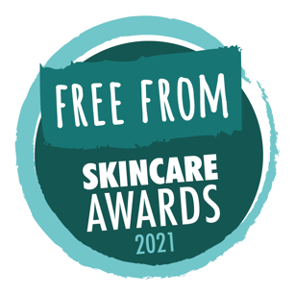
PRESS RELEASE: July 8th, 2021

Winners announced in 2021
Free From Skincare Awards

Irish handmade skincare brand Holos Skincare has triumphed in the tenth annual Free From Skincare Awards, winning Best Free From Skincare Product for This is More Get Better Butter.
“A little pot of loveliness,” said one delighted tester. “If I were shipwrecked on a desert island, this would be the one luxury item that I could not do without.”
The Best Free From Brand Award was shared between Lyonsleaf, winners of almost 30 medals in the history of the Awards, and Australian brand Eco by Sonya, who bagged a Gold and two Silvers with their three entries this year.
Free from artificial fragrances, colours, animal-sourced ingredients, palm-oil derivatives and food allergens, Holos’s Get Better Butter beat stiff competition from other category winners, including products by first-time participants Scence, Grace & Blumë and Made on the Chalk, and Award regulars Hairy Jayne, Weleda and Fiini Naturally.
“Scoring an average of 9.6 out of 10 with our product testers, Get Better Butter deserved the overall title this year,” said Awards director, Alex Gazzola. “The wonderful texture was admired by all, and the results reported were exceptional.”
All Gold, Silver and Bronze winners can be found at www.freefromskincareawards.co.uk/winners-2021

Notes for Editors:
Product shots, logos and lists of winners are available at www.freefromskincareawards.co.uk/2021-press-pack

Holos Skincare is based in Co. Wexford, Ireland, and was founded by Niamh Hogan. See www.holos.ie for further information.

The Free From Skincare Awards were launched in 2012 to encourage and reward manufacturers of skincare products that are ‘free from’ some of the allergens, ingredients, additives and artificial fragrances which consumers with skin sensitivities, health concerns, as well as ethical, personal and environmental values, would like to or need to avoid.

They were founded by Michelle Berriedale-Johnson, director of the Free From Food Awards and Alex Gazzola, a writer specialising in allergies and ‘free from’.

Entries for the 2022 Awards open in February.

For further information, or to speak with Niamh Hogan of Holos, please contact Alex on alex@freefromskincareawards.co.uk

Twitter: www.twitter.com/FFSkincareAward
Facebook: www.facebook.com/FreeFromSkincareAwards
Instagram: www.instagram.com/freefromskincareawards

