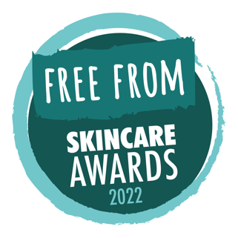
PRESS RELEASE: July 20th 2022

Winners announced in 2022
Free From Skincare Awards

British spa skincare brand SenSpa has triumphed in the eleventh annual Free From Skincare Awards, crowned overall champion and Best Free From Skincare Product 2022 for their Relaxing Talc Free Body Powder.
“Leaves an amazing silk-like feel to skin,” said one delighted product tester. “The fragrance oozes relaxation. Gave an extra elegance to my daily routine.”
The Best Free From Brand Award was won by North Wales’s Rhug Wild Beauty, which won an unprecedented two golds and three silvers in the individual product categories.
Free from artificial fragrances, colours, animal-sourced ingredients and food allergens, SenSpa’s winning product beat stiff competition from other category winners, including products by first-time participants LUMI (from Estonia), MERME Berlin (Germany) and White Moon Skincare (Jersey).
“It was perhaps inevitable that the Relaxing Talc Free Body Powder would eventually win,” said Awards Director, Alex Gazzola. “It won Gold in its category in 2016, as well as in 2018, and this year too — again and again and again it has impressed testers and judges alike.”
All winners and medallists can be seen at www.freefromskincareawards.co.uk/winners-2022

Notes for Editors:
Product shots of winner / runners-up, logos and lists of winners are available at www.freefromskincareawards.co.uk/2022-press-pack

The Free From Skincare Awards were launched in 2012 to encourage and reward manufacturers of skincare products that are ‘free from’ some of the allergens, ingredients, additives and artificial fragrances which consumers with skin sensitivities, health concerns, as well as ethical, personal and environmental values, would like to or need to avoid.

They were launched by Michelle Berriedale-Johnson, founder of the Free From Food Awards and Alex Gazzola, an author specialising in allergies and ‘free from’.

Entries for the 2023 Awards open in February.

For further information, or to speak with Lina Lotto from SenSpa, please contact Alex on alex@freefromskincareawards.co.uk or call 07783 108745

Twitter: www.twitter.com/FFSkincareAward
Facebook: www.facebook.com/FreeFromSkincareAwards
Instagram: www.instagram.com/freefromskincareawards

